1. Dow can be seen in any timeframe.
2. It can be seen b/w two candles.
3. A graph on a white board

   Description automatically generated
4. A diagram with red arrows and text

   Description automatically generated with medium confidence
5. 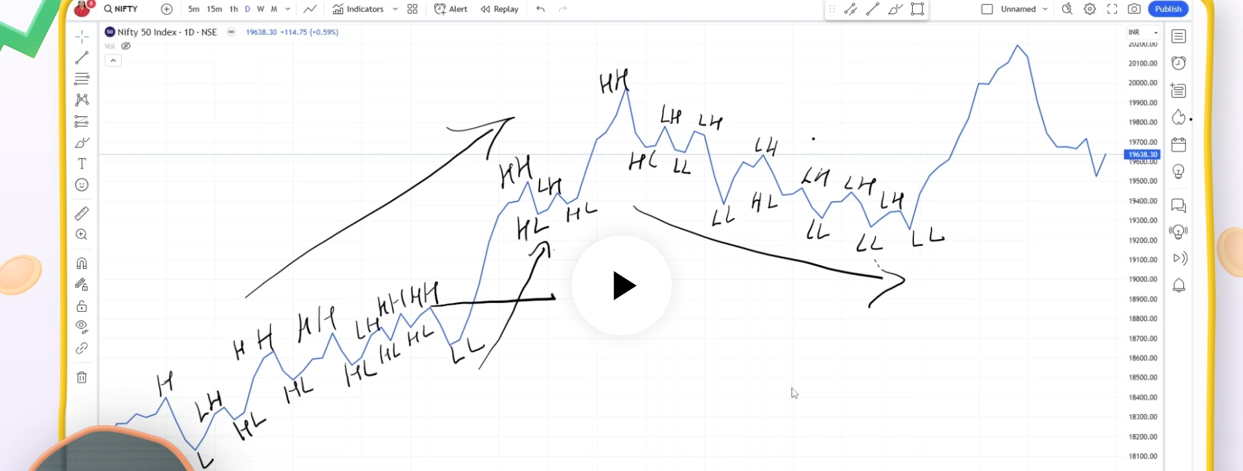
6. 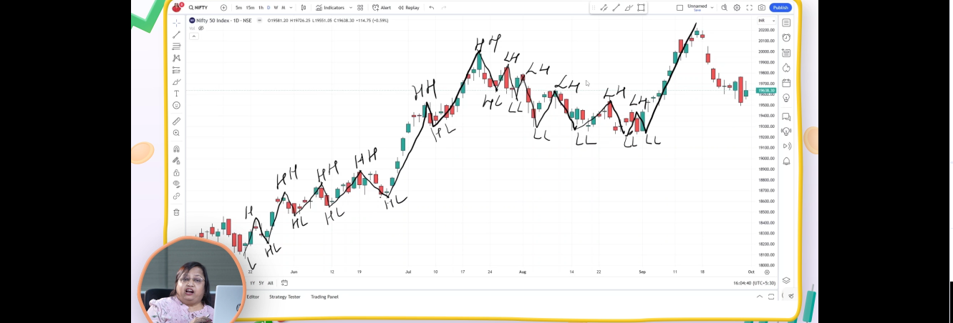
7. Thus DOW Theory gives us an indication where the trend will go up or down based on the breakage of HH, HL in case of uptrend and LL, LH in case of downtrend.